***Final Testing***

**Index**

**1 - Main Form**

Start Screen

Inputting Money

* Insufficient Funds
* Exact Change
* Change Available: Breakdown of Change Screen
* Change Unavailable

Succesfull Transaction

Return Coins

**2 - Help Screen**

English Instructions

Italian Instructions

**3 - Login Screen**

Incorrect Credentials Entered

Correct Credentials Entered

**4 - Manager Screen**

Invalid Input

Adding Drinks

* Adding Drinks
* Successfully Added Drinks
* Drinks Overstocked

Adding Coins

* Adding Coins
* Successfully Added Coins
* Coins Overstocked

Removing Coins

* Removing Coins
* Successfully Removed Coins
* Coins Understocked

Updating Price

* Updating Price
* Price Updated

**5 - Report Screen**

Final Report

**Images**

**Main Screen**

Start Screen

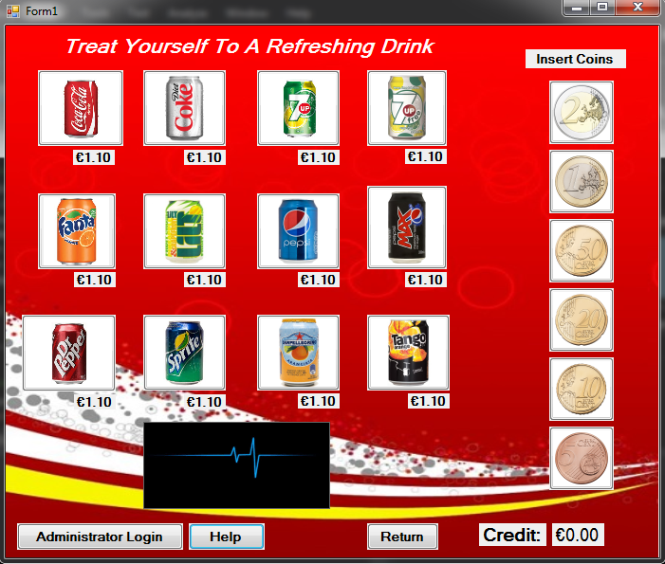

Inputting Money

* Insufficient Funds

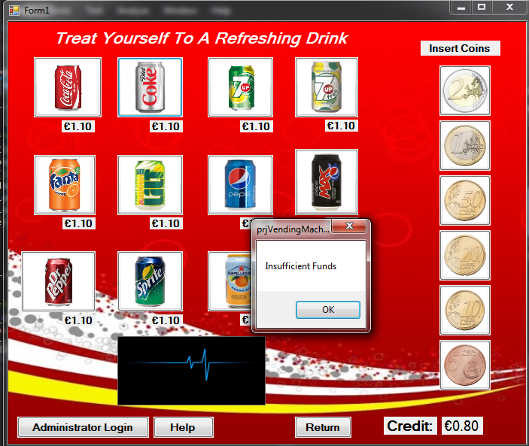

* Exact Change

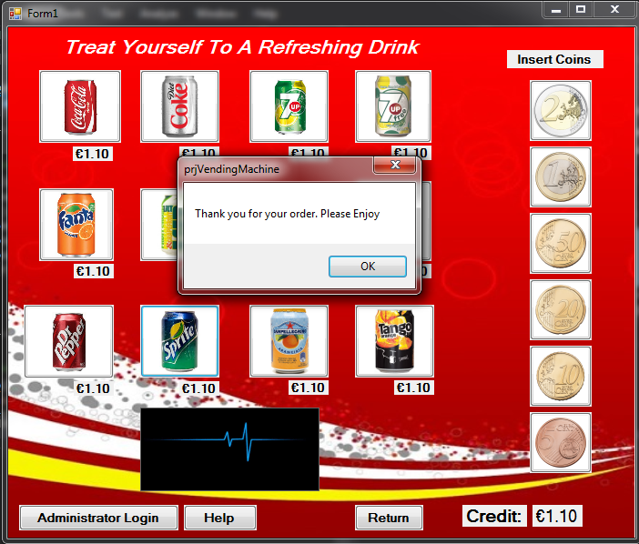

* Change Available: Breakdown of Change Screen

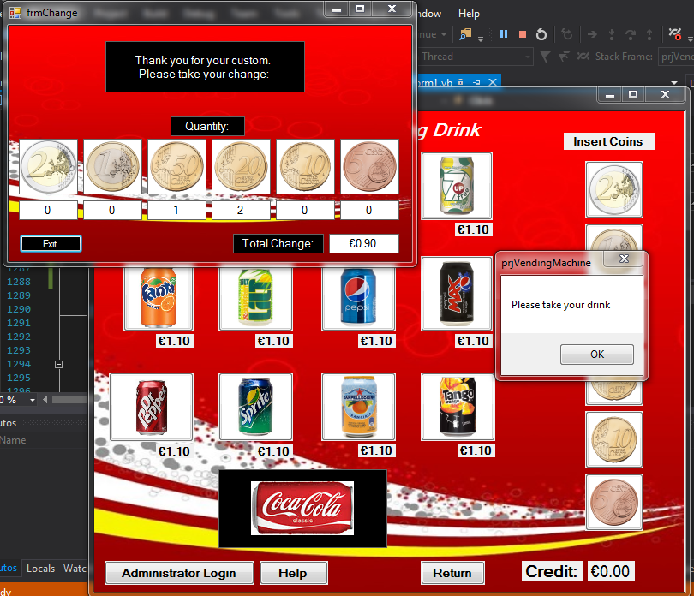

* Change Unavailable

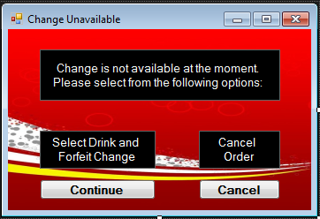

Succesfull Transaction

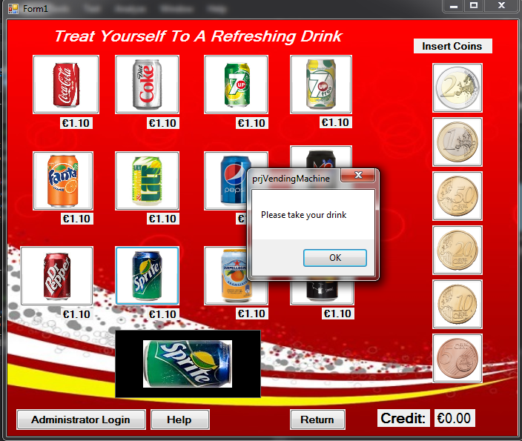

Return Coins

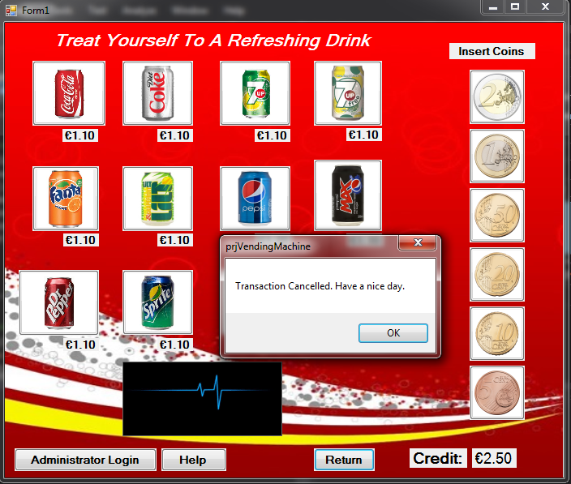

**2 - Help Screen**

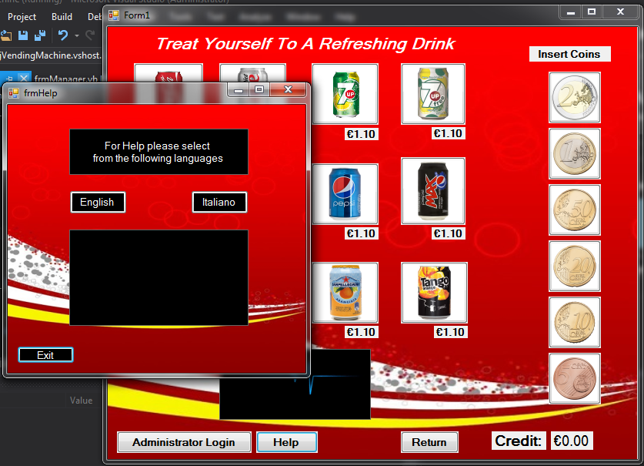

English Instructions

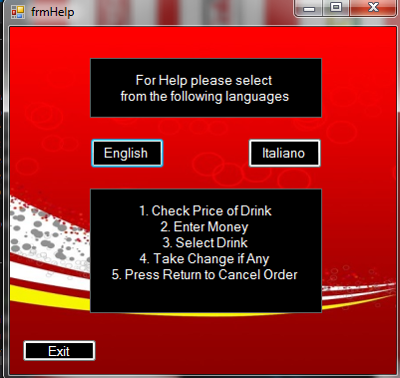

Italian Instructions

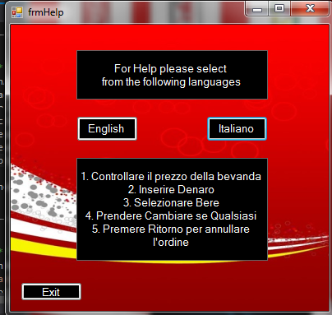

**3 – Login Screen**

Incorrect Credentials Entered

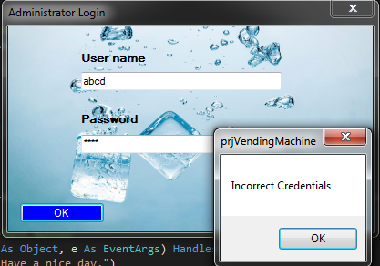

Correct Credentials Entered

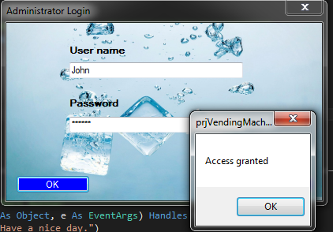

**4 - Manager Screen**

Invalid Input

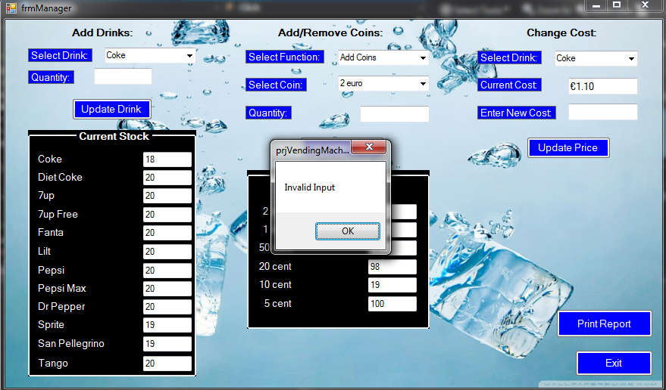

Adding Drinks

* Adding Drinks

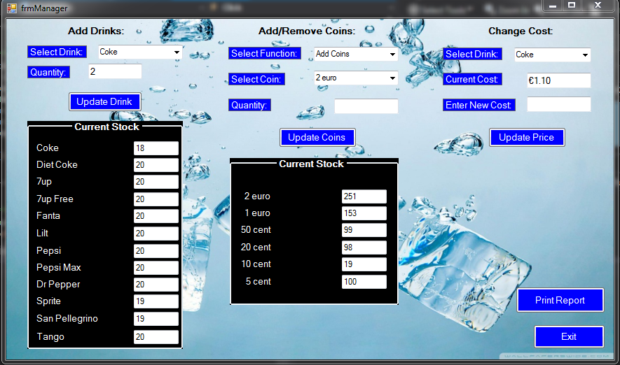

* Successfully Added Drinks

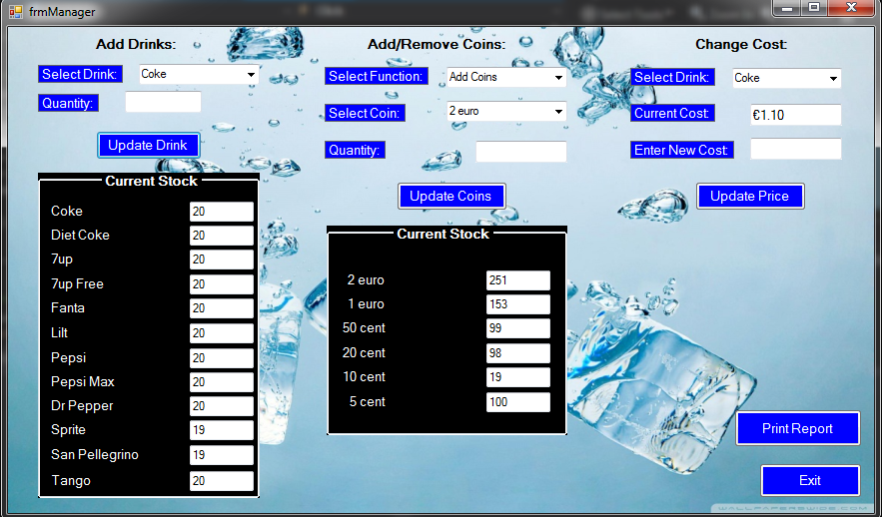

* Drinks Overstocked

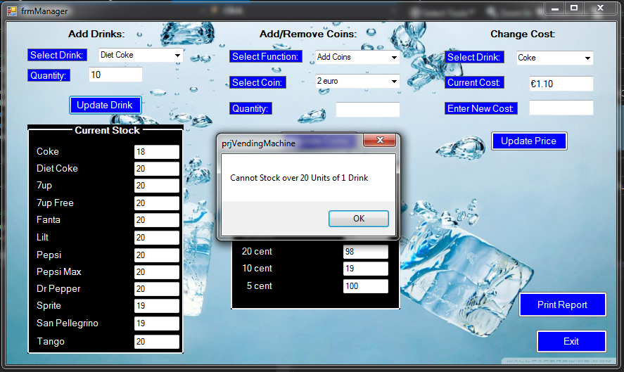

Adding Coins

* Adding Coins

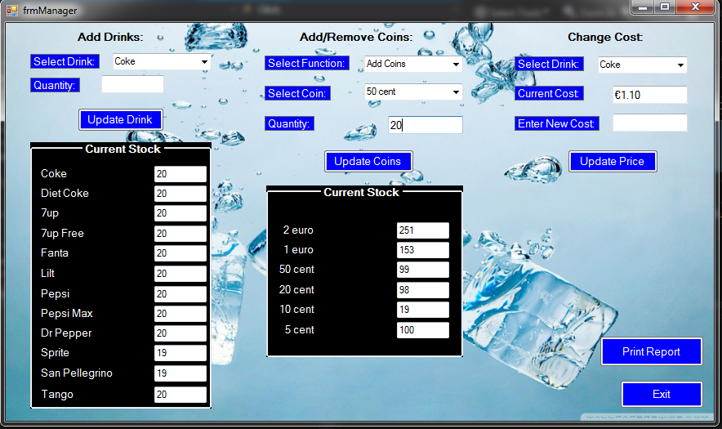

* Successfully Added Coins

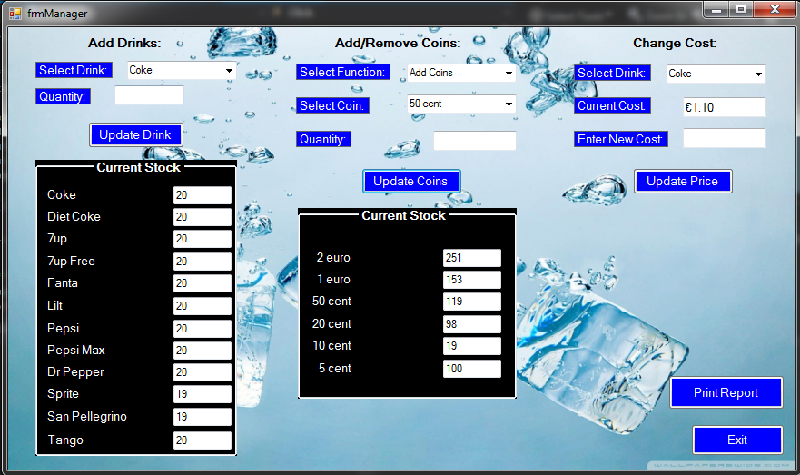

* Coins Overstocked

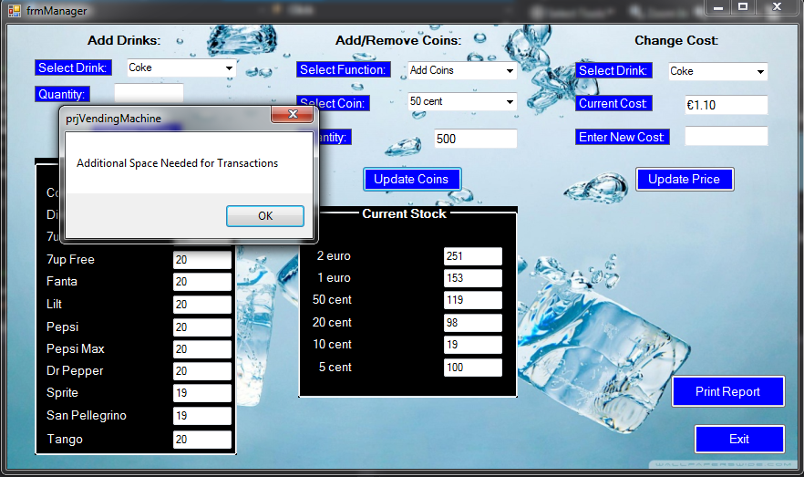

Removing Coins

* Removing Coins

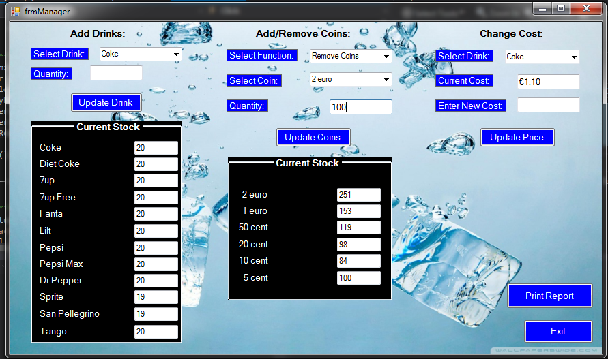

* Successfully Removed Coins

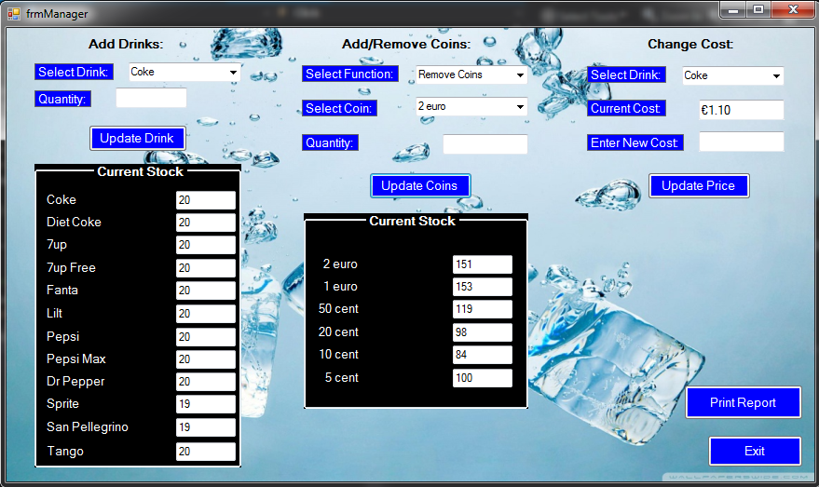

* Coins Understocked

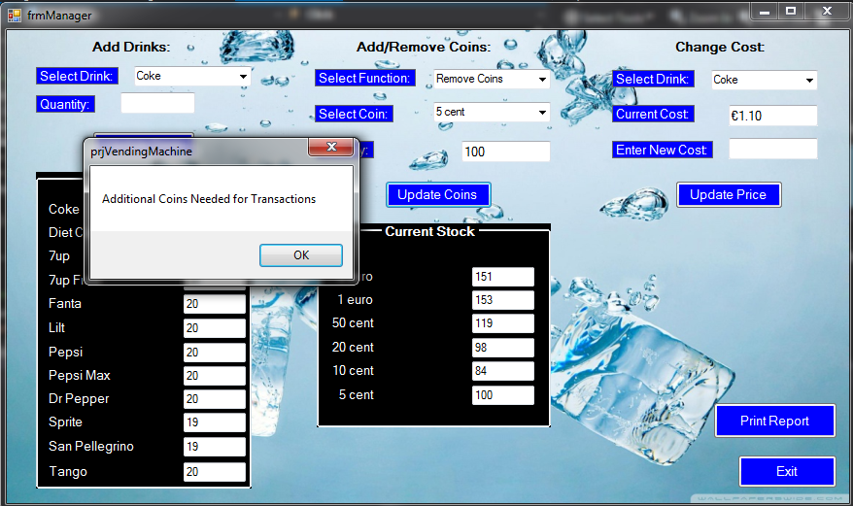

Updating Price

* Updating Price

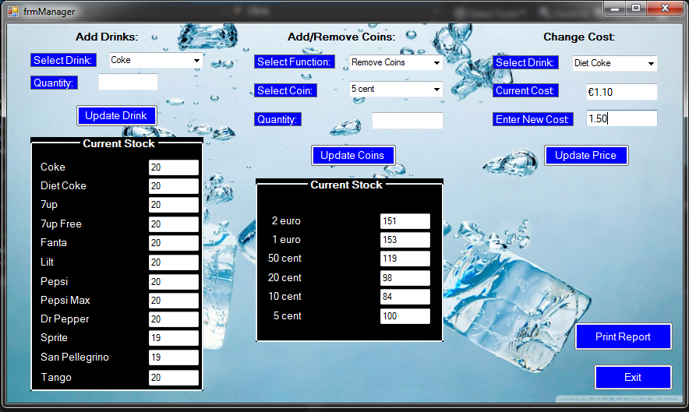

* Price Updated

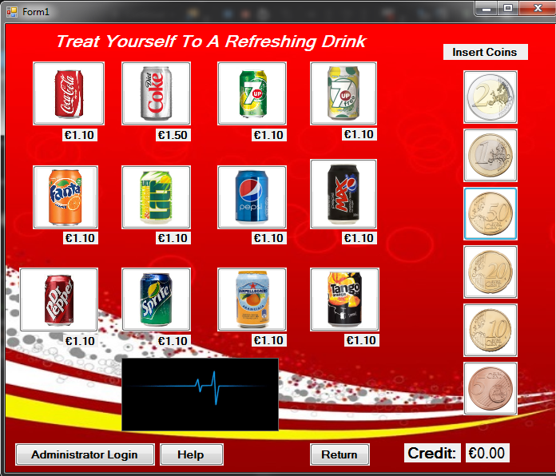

**5 - Report Screen**

Final Report

